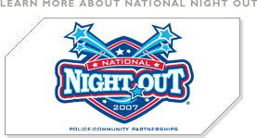
National Night Out 2007
Take back the Neighborhoods
Date: 08/07/2007
Time: 6:00 to 8:30 pm
With: Assistance provided by the
Charles Village Civic Association
("CVCA"), and the Charles
Village Community Benefits
District ("CVCBD") and visits
from City Officials, Northern
District Police and the CVCBD
Safety Team.
Reply: Sign up as a Charles Village
Block Leader by contacting
Sharon L. Guida, CVCA Board
Member and National Night
Out Coordinator before July
31at SLG2700@cs.com or at
410-889-0436.
More:http://www.nationalnightout.org
for the history of
National Night Out.
What: Neighborhood Block Party
Leaders Needed
For: 24th National Night Out Against
Crime, Tuesday, August 7, 2007
To: Hold a block party/cookout for your neighbors on your front porch from 6 p.m. to 8:30 p.m. designed to heighten crime prevention awareness, to generate support for, and participation in, local anticrime programs, to strengthen neighborhood spirit and police-community partnerships, and to send a message to criminals that your block is
organized and
fighting back.

