Indulge yourself in a
Sunday evening of superb jazz featuring San Francisco’s
GAUCHO
Starring ~~
- Dave Ricketts, guitar
- Ari Munkres, standup bass
- Rob Reich, accordion

Sunday, November 3, 2013
7:30 pm
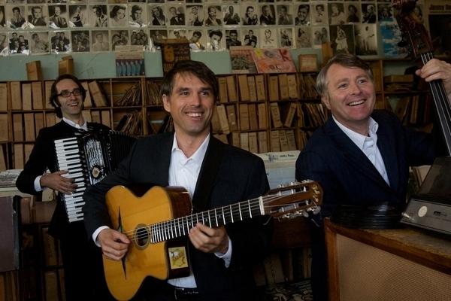

St. Mark’s Lutheran Church
St. Paul at 20th Streets, Baltimore
www.stmarksbaltimore.org

Presented without charge* by the St. Cecilia Society of St. Mark’s Lutheran Church
*Free will contributions accepted.

Parking available on street and at church parking lot on 20th Street at St. Paul.
Indulge yourself in a
Sunday evening of superb jazz featuring San Francisco’s
GAUCHO
Starring ~~
- Dave Ricketts, guitar
- Ari Munkres, standup bass
- Rob Reich, accordion

Sunday, November 3, 2013
7:30 pm

St. Mark’s Lutheran Church
St. Paul at 20th Streets, Baltimore
www.stmarksbaltimore.org

Presented without charge* by the St. Cecilia Society of St. Mark’s Lutheran Church
*Free will contributions accepted.

Parking available on street and at church parking lot on 20th Street at St. Paul.

